

We knew. Anne to come. Anne to come. Be new. Be new too. Anne to come Anne to come Be new Be new too. And anew. Anne to come. Anne anew. Anne do come. Anne do come too, to come and to come not to come and as to and new, and new too. Anne do come. Anne knew. Anne to come. Anne anew. Anne to come. And as new.

Kamratōn presents:

be new too.

7:00 p.m. Sunday, November 11, 2018

St. Paul of the Cross Monastery

148 Monastery Avenue, Pittsburgh, PA

Kamratōn’s 2018-2019 is made possible by

The Pittsburgh Foundation and The Heinz Endowments.

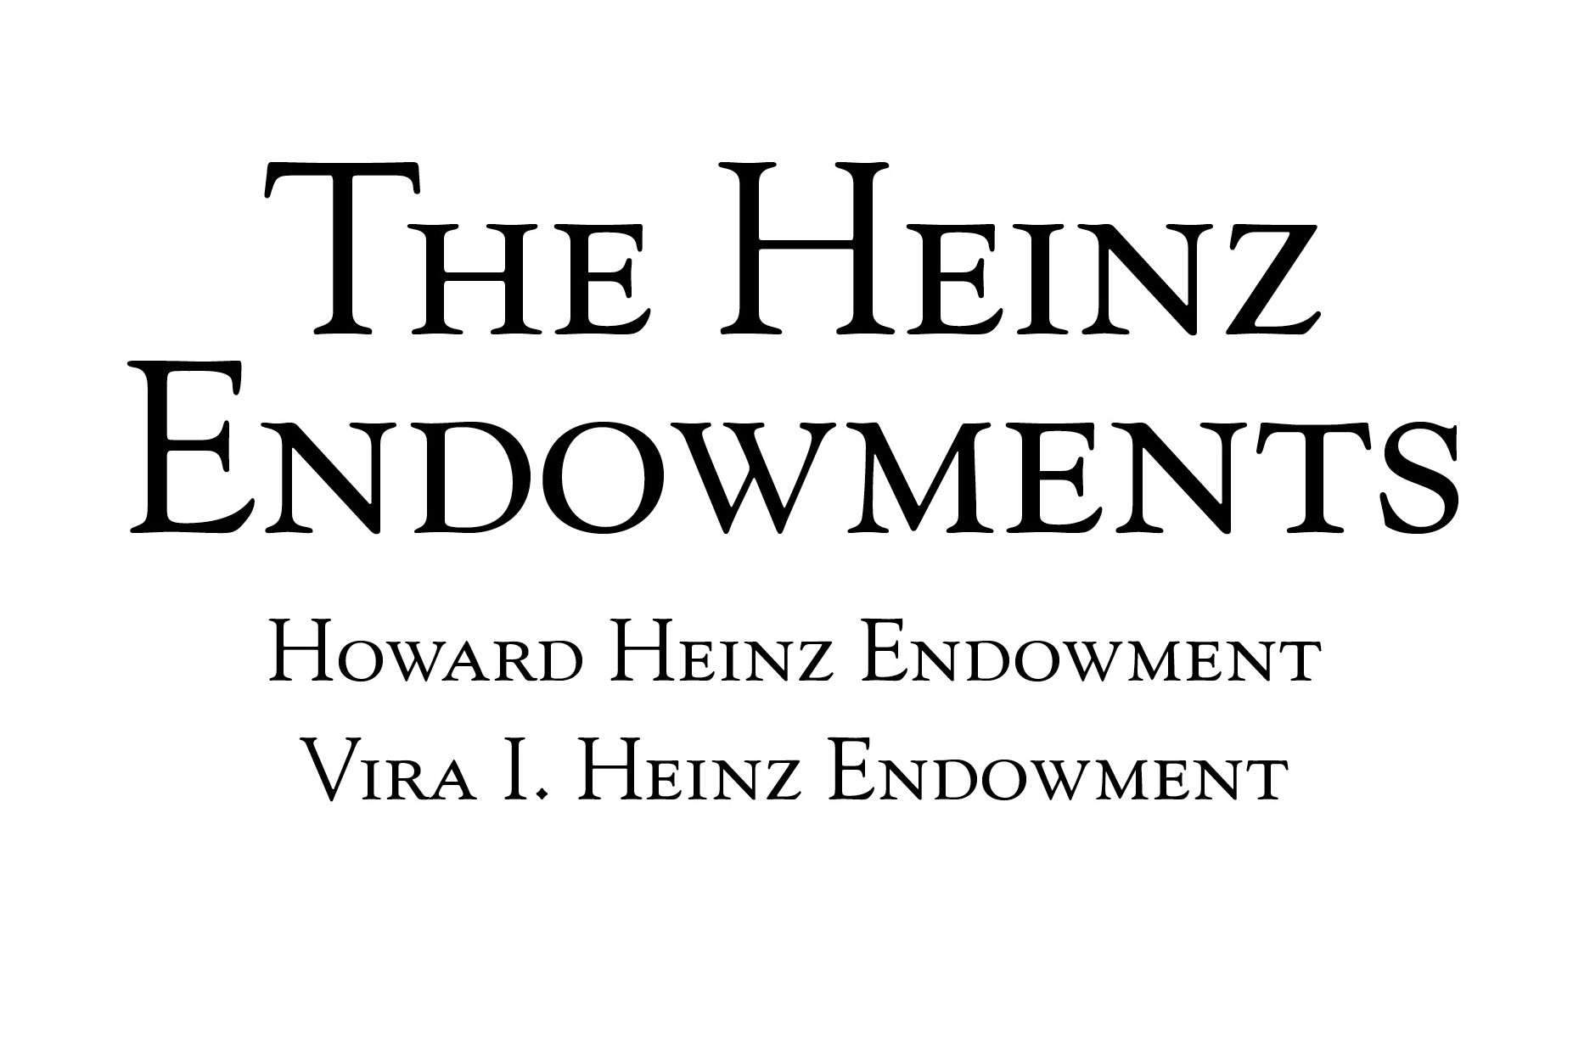

Upcoming Concerts:

https://www.kamraton.org/events.html

**Kamratōn Musicians**

Jennifer Sternick, violin

Cecilia Caughman, cello

Sarah Steranka, flutes

Emily Cook, clarinets

Anna Elder, soprano

**Special Guest Musician**

Benjamin Cornelius-Bates, piano

**Program Notes**

“be new too” is an evening of pieced-together sounds, sometimes visceral and intense, sometimes overheard from afar. We open with *Cranks and Cactus Needles* by Annie Gosfield. Gosfield writes that she “was inspired by the sound of ancient 78 RPM records, and the pops, scratches, skips and warps that occur as they deteriorate,” and instructs the musicians to sound “distant and ghostly, like a Victrola down the hall.” This concert also features thirteen brand-new works, all providing a glimpse of a poem, “New” by Gertrude Stein. Stein’s poem whimsically asks readers to play along with Stein’s linguistic tricks, just as the ensemble invites the audience to listen with openness to these tremendously varied new works. Though certainly unforeseen, this concert’s theme of openness and collaboration have taken on a new sort of relevance in the wake of tragedy that Pittsburgh’s Jewish community, and the entire Pittsburgh community, suffered on October 27. Though we recognize how small a part we may play, we hope that through art, we can practice responding with openness to that which is unfamiliar or to that which we do not initially understand, and that we can model a society that is strengthened through its diversity.

*We dedicate this concert to the victims of the Tree of Life shooting, and, on Veteran’s Day, honor the courageous men and women whose commitment to the ideals of equality and democracy was far stronger than hate and fear.*

Program

Cranks and Cactus Needles (2000) Anne Gosfield

Miniatures on “New” (2018)

ONE Lucie Vítková

Duo                  Christine Burke

Take the Place Gay Kahkonen

Duet on Stein Roger Dannenberg

to come to Marina López   
New 6 Brian Riordan

New Devon Tipp

As far. / So far. Benjamin Cornelius-Bates

Interrupted Andrés Carrizo

[a]new (excerpt) Zvonimir Nagy

Not so far as to mean. Emily Cook

When Erin Cameron

Be new too (2018) Ramin Akhavijou